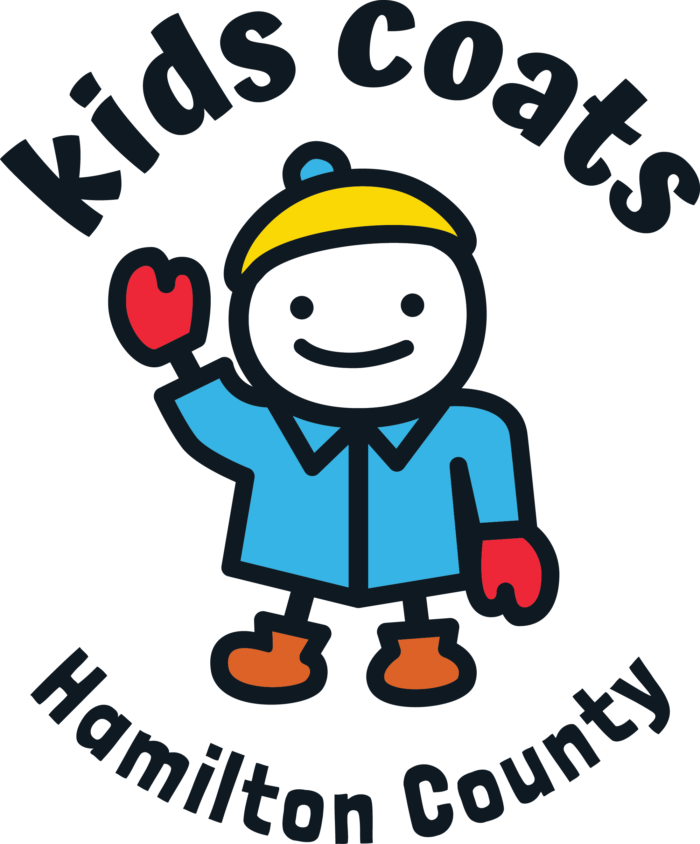Your Organization
Making a difference in our community!
We need your clean coats, mittens, gloves, hats, and boots!
ALL SIZES: from infant sizes to adult 5XL

Place donated items
Location: _______________________________________________

Dates of Collection: ____________________________________

Thank you for your contribution!

Help keep our Hamilton County families warm this winter!

Donations will be distributed:
October 28 – Arcadia
Arcadia Brethren Church 8989 East 266th Street
October 28 – Westfield
CrossRoads Church Westfield 19201 Grassy Branch Rd
November 5 – Carmel, Fishers, & Sheridan
Carmel United Methodist Church 621 S. Rangeline Road
St. Louis de Montfort Catholic Church - 11441 Hague Road
Sheridan First United Methodist Church 207 E. 2nd Street
November 18 – Noblesville
Green Valley Church of Christ 19005 Cumberland Road
For more information see:
kidscoats.org

